GUIDE TO USING SIMBA
Getting started:
Download the latest version from GitHub: https://github.com/BuckeyeCurrent/Simba/archive/master.zip
Once the zipped folder has been downloaded, unzip the folder by right clicking it and clicking Extract All.

Running SIMBA:
Run SIMBA.exe in the downloaded folder.
Starting SIMBA may take a while the first time. Be patient

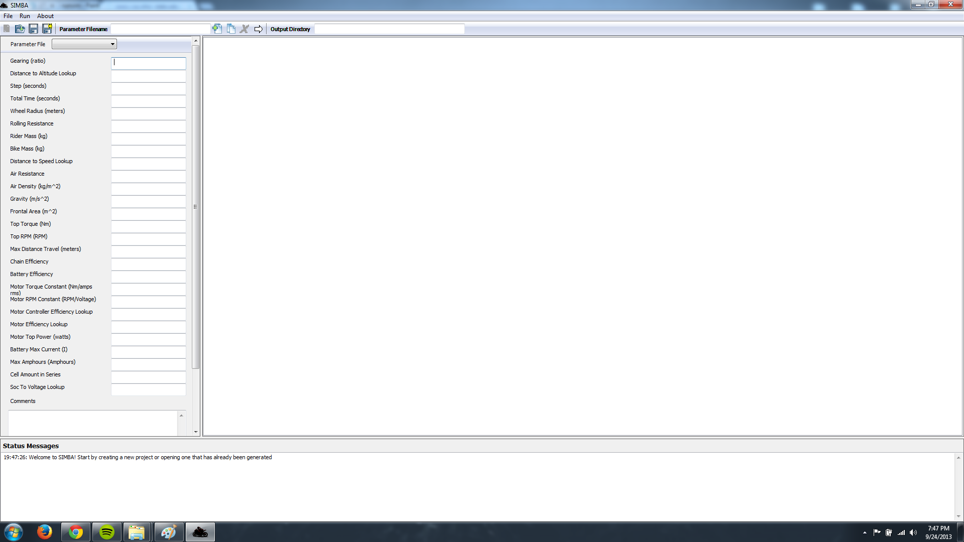
SIMBA should open after it finishes loading. There should be three main panels. The left panel is also known as the input panel. This is where the user will enter and change parameters. On the right, is the output panel. This panel shows the results from the simulation. Lastly, there is a status panel on the bottom which updates the users about what the program and user is doing.

TO START:

The image above shows the “toolbar” which essentially holds all the main tools a user will need while using SIMBA. From left to right the tools are as follows:

New Project (Unavailable in initial release)
Open Project: Opens an existing project a user has made or a template
Save Parameter File: Saves only the parameter file in the input panel
Save All Parameter Files: Saves all parameter files in the project
Parameter Filename: Name of new parameter file user wants to create
New Parameter File: Create a new parameter file with empty parameters
Copy Parameter File: Create a new parameter file by copying current file in input panel
Delete Parameter File: Delete the current parameter file in the input panel
Run Simulation: Run the simulation with the current parameter files in the project
Output Directory: Save directory of the simulation results displayed in the output panel

To get started, open the template project located in the folder you downloaded. To do this, look for the Open Project button in the toolbar. You can find the template project in the test_in folder which SIMBA.exe is located with. From there, pick one of the projects folders and then open “OPTIONS.csv”. The OPTIONS.csv file is the project file pointing to the files that make up the project (parameter files)
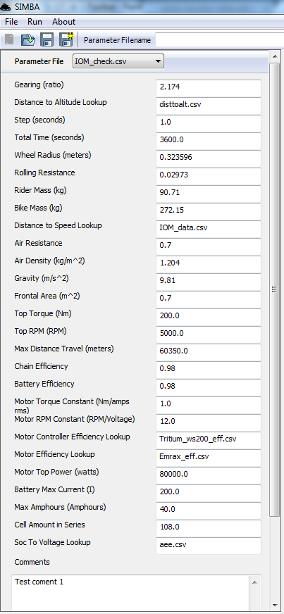
At this point, the input panel has been populated with the data in the template project parameter files. All the values of each parameter file can be edited. To change a value, simply replace it with a value of your choosing. To save changes to a parameter you have made, simply click Save or Save All in the toolbar. Note: Certain parameter values may cause SIMBA to downscale the value to the max value in a corresponding lookup file. In this event, a warning message will be displayed in the status panel with the corresponding parameter file the error occurred in.
Each parameter file in a project can be found in the drop down list located just under “Open Project”. Using the picture to the left as an example, the user would click TestTemplate.csv to open the drop down list and select another parameter file.
The comments field in each parameter file allows the user to specify any notes they wish to incorporate with a test. The comment field will then be transferred to the output files after the simulation is ran.

New, Copy, and Delete Parameter Files
A new feature with SIMBA is the ability to add and remove parameters files directly from SIMBA itself. A new parameter file is an input file in a project that is ran through the simulation. The parameter files hold the data the simulation needs to run.
To add a new parameter file, there are two options: New Parameter File and Copy Parameter File. Both of these tools require a Parameter Filename. This is the name of the parameter file to be created. Once a filename has been entered into the Parameter Filename field, click either the New Parameter File or Copy Parameter File button on the toolbar.
New:
The New Parameter File will create a new blank parameter file. All of the values in this new parameter file must be populated with input except for the optional comments field.
Copy:
The Copy Parameter File will create a copy of the current file shown in the input panel. For example, if TestTemplate.csv is currently open in the input panel, all the values from that parameter file are then copied to the new parameter file with the name specified in Parameter Filename.
Delete:
Lastly, the user can also delete a parameter file. Clicking the Delete Parameter File button in the toolbar will remove the current parameter file in the input panel from the project. This will NOT delete the parameter file from the user’s hard drive.
Note: The filename must end in .csv (Comma Separated Values file format). An example of a correct filename is new_test.csv. An incorrect filename is new_test.
Running the Simulation
After the parameter files have the desired values, simply hit the white arrow button called Run Simulation. The simulation process could take anywhere from 30 seconds to 5 minutes depending on how many parameter files are in the project file you are working on. The results will then display in the right output panel. All the data found here can also be found in the Output Directory specified for the project. If you wish to save the files somewhere else, you can change the field to where you want the parameters output files to be saved. WARNING: Be careful setting the Output Directory to the same directory the input files are located in. Doing so could overwrite your input parameter files.
By default the Output Directory will be the in the test_in folder of the project folder.
Running a Sensitivity Analysis
A sensitivity analysis can be ran on each of the parameter files in a project. This sensitivity analysis takes each parameter from each parameter file, adjusts the value by +X% and -X% and then runs the simulation with only that change. This continues through all the input parameters until a full list of simulations have been generated for each parameter file. The results are then processed and sorted in order to show which changes generated the largest or smallest change for the selected output parameter.
To toggle a sensitivity analysis, simple check the Sensitivity Analysis option on the menubar. You should then specify a new adjustment value.
The sensitivity analysis can then be ran by clicking the Run Simulation button. Please wait as this is a long process. 60+ simulations are being ran with this process.
After the sensitivity analysis has completed, a new window should pop up.
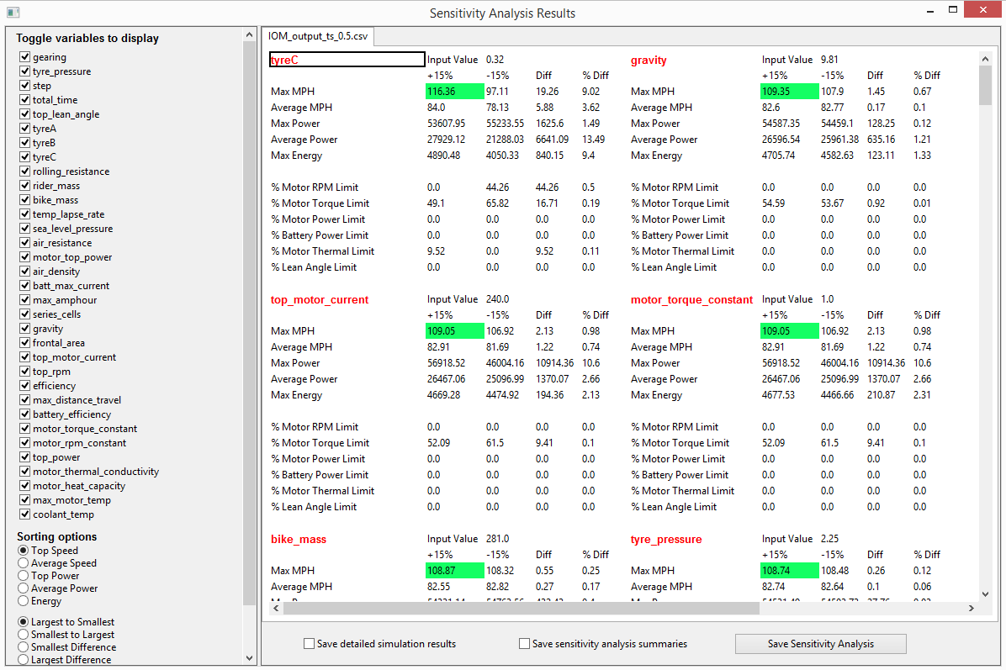
There are many new features available with the sensitivity analysis. To start, an input parameter list is available to on the left panel. This list allows you to select which input parameters you currently want to see in the sensitivity results. For example, let's say you don't want to see Tyre C, Tyre B, or Tyre A. You can select those input parameters and they won't be shown in the analysis. Farther down on the left panel are the Sorting Options. This options allow you to sort the results based off speed, power, energy and the order. In this case, since Top Speed and Largest to Smallest are selected, the parameters that affect top speed the greatest are listed first. The top speed values are also highlighted green to quickly locate the values.
Since the sensitivity analysis may contain warnings for each run, it was important to create a way to show the warnings that happened during each parameter adjustment. Parameters that ran into a simulation warning are colored red. To see the warnings for that parameter, simply highlight over the red text and a list of runtime warnings will be displayed.
Lastly, it's possible to save either all of the full simulation runs performed on each parameter or to simply save the sensitivity analysis report as you are currently viewing it. Simply select the checkbox option and select the Save Sensitivity Analysis button.
TO CREATE A NEW PROJECT:
Copy and Paste the “Project Template” folder to the project location you want. The new folder can be renamed to anything you want. The OPTIONS.csv folder inside however must remain the same name. Opening the project is the same as before.

